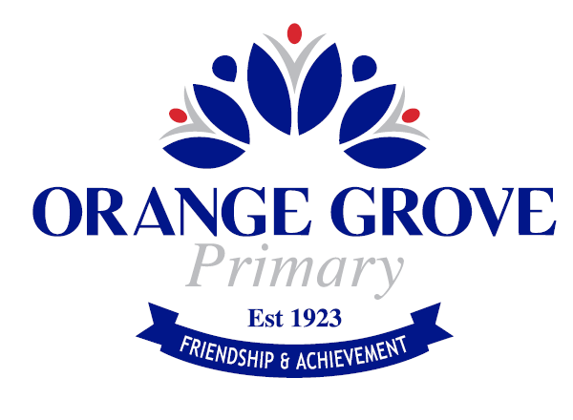 Charges for Extra Cost Options – Schedule 2024
The term ‘charges’ refers to the extra cost of activities which are part of the educational program and which contributions do not cover. Listed in the table below are the extra cost optional activities that students may have the opportunity to participate in during 2024.

A breakdown of estimated maximum charges for your child’s participation in excursions, incursions and activities for 2024 have been included in the table below. The estimated costs provided are an upper limit and will not exceed this amount. Classroom teachers will organise excursions/incursions to support the teaching and learning program as appropriate. Students will only occur costs when they are involved in a particular activity and payment will be requested during the year when the event takes place.

Charge Items | Kindy | Pre Primary | Year 1 | Year 2 |  | Year 3 | Year 4 | Year 5 | Year 6
Excursions for the year – no more than: | $60.00 | $60.00 | $60.00 | $60.00 |  | $60.00 | $60.00 | $60.00 | $60.00
Incursions for the year - no more than: | $50.00 | $50.00 | $50.00 | $50.00 |  | $50.00 | $50.00 | $50.00 | $50.00
Interm Swimming – no more than: |  | $90.00 | $90.00 | $90.00 |  | $90.00 | $90.00 | $90.00 | $90.00
Interschool Events – no more than: |  |  | $40.00 | $40.00 |  | $40.00 | $40.00 | $40.00 | $40.00
Soundwave Books |  | $10.00 | $15.00 | $15.00 |  | $15.00 | $15.00 | $15.00 | $15.00
IMaths Books |  | $10.00 | $15.00 | $15.00 |  | $15.00 | $15.00 | $15.00 | $15.00
PEAC Program – Selected Year 5/6 Students |  |  |  |  |  |  |  | $300.00 | $300.00
Year 5/6 Camp (2025 Camp) |  |  |  |  |  |  |  | $400.00 | $400.00
Year 6 Graduation Shirt – no more than: |  |  |  |  |  |  |  |  | $50.00
Year 6 Graduation Lunch – no more than: |  |  |  |  |  |  |  |  | $60.00
Other Option: Years 5 – 6 - iPad and Keyboard, see Administration for additional details.

